Orchestra II Disclosure 2023-24 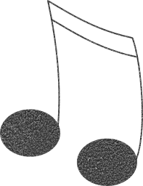

Mrs. Michelle Misco, room 2033, Orchestra
Office hours Tuesday and Thursday from 2:30-3:00. Email is the best way to reach me, as I teach at 4 schools. michelle.misco@slcschools.org Please allow up to 24 hours for a response outside of office hours, but I do check my email several times per day.

Course Description: In Orchestra II class, students will be continuing to learn to play a string instrument in a group setting. This class is not for beginning students, they should be continuing to play the violin, viola, cello, or bass and should have note-reading skills. Students will also continue to learn how to read more advanced rhythms and musical terms, and most importantly, to rehearse and perform as a group. Becoming a better musician is the main goal of this class.

Course Goals: 1) The students will continue to learn to hold their instrument and bow properly (as needed), to produce a better quality sound and how to use advanced bowing techniques. Some students may work on shifting and vibrato as they are ready. All students will reinforce previous skills as well as learn how to become more musical while playing with a group, and to improve intonation, balance, and blend.
2) The students will learn how to read and use advanced musical notation. They will be expected to already know their lines and spaces, note values, and how to read notes on all strings. They will also learn advanced musical terms and symbols, such as dynamics, tempo and articulations and how to express them.
3) The students will learn to play and perform as a group. They will learn about balance and blend, intonation, as well as keeping tempo and following a conductor.
They are required to participate in all school concerts and festivals. Please mark all dates on your calendar.

Course Materials: All written class materials will be provided by the teacher. Each student must have a folder to put their sheet music I (I have folders if they need one), book and worksheets in. It is their responsibility to replace any lost music. Sheet music is $2.00 per piece, and the book is $9.00 to replace. Students are expected to bring their folder, instrument and pencil to every class.

Procedures: Orchestra class is an experience-based class. This means that students need to participate in class rehearsals in order to earn a grade. Students will learn new ideas in every class, which need to be practiced at home in order to participate fully in the next class. All students must practice at least 3-4 days per week for a total minimum of 80 minutes per week at home. Unprepared students will not be able to fully participate, and may only make up 70% of participation points with a written assignment. Be on time! Late students who miss instruction will lose partial participation points for that day. There will be three school concerts per year, as well as the Open House, District Festival, assemblies during school and the Lagoon Music Festival.

Orchestra II Grading: Students will be graded on the following:

Participation (30%)– Demonstrating effort in class by being prepared with their instrument, folder with music and book, and pencil for class, as well as participating in class activities and school concerts. Students without instruments will be required to complete a written assignment that day for partial (70%) participation credit. Parents will be notified after 2 times, and will be expected to help their child be prepared for classes. Unexcused absences also impact participation. They will miss instruction and valuable rehearsal time, and will need to make up for their absences with a written assignment about our current pieces to receive partial participation credit.
Improvement and written assignments (40%)– Demonstration of regular progress of course goals throughout the semester with playing tests on Canvas and group playing in class as observed and assessed by the teacher. Students who are not making regular progress may be asked to play more often for the teacher. The teacher will also contact parents about home practice habits.. Written work will be done in class to work on notation skills and will be turned in for a grade on a regular basis.

Concerts (30%) -Grade based on attendance, preparation and participation. Students must attend school concerts. The culmination of our hard work together is performing. If a student needs to miss one concert for an unavoidable and important conflict, written notice must be given to the teacher at least 2 weeks prior to the concert. A written project and performance will need to be completed within a week of the missed concert to receive partial concert credit. Illness can be made up with a project, so please communicate with Mrs. Misco.
My website can be visited at: Hillsideorchestra.weebly.com (please bookmark this now) This webpage will include all concert dates, important information, video tutorials, concert videos and resources. Concerts will also be on the Hillside calendar.
Concert policies- Orchestra II:

The Concerts during the school year are MANDATORY. All Orchestra students are expected to participate as part of their grade. Attendance is vital to the success of the group. Students may not make up an unexcused absence from a concert. Illness may be made up, please contact Mrs. Misco if your student is ill.

Dates: (put these in your calendar today and look for an email with later dates)

December 12th - Winter Concert at Hillside 7:00pm (concert black) call 6:30pm
January 25th - Open House at Hillside, report 6:15, play 6:30-6:45pm (wear t-shirt)
March or April TBA- District Orchestra Festival- during school hours, information will be sent a month before- concert black
May 14th - Spring concert at Hillside 7:00pm (concert black) call 6:30pm
Lagoon- Music in the Parks- optional event on May 18th (letter will come home and email with details and cost) (wear t-shirt)

Night Concert and Festival dress code:
Concert black: (or black and white)
As with any sport or dance, we wear a uniform to keep the audience focused on the performance, not any single person. We want them to see a unified looking group. This is your uniform.
Option 1 white or black button up shirt or polo shirt or plain black top with no logos black or dark grey pants (not jeans unless SOLID black, not faded) and dark dress shoes. Ties are optional, but look great. NO logo shirts, or anything that does not meet school dress code. Shirts should be all one color and not sleeveless.
Option 2 black or white sweater or dress top (not t-shirt or tank top) and black skirt (knee length or longer) or a black or black and white dress. Neutral colored dark dress shoes. No midriff baring, very short or strappy dresses or shirts, must follow school dress code.
****If you need any concert attire, please email Mrs. Misco as soon as possible. We have a large collection of gently used concert clothing that has been donated for students at Hillside. We would be happy to help!

Attendance is expected from all students at concerts. If a student must miss one performance for an unavoidable conflict of great importance, Mrs. Misco must receive written notice at least 2 weeks before the concert to receive a make-up project. There will be a few other school day assemblies at Hillside, which will be announced at least 2 weeks prior to the performance and will be during the school day.
ADDITIONAL INFORMATION:
Academic Honesty: All SLCSD students are expected to be honest in their academic endeavors. Assignments and assessments should represent the work of the learner.
Acceptable Use of District Electronic Devices: A student should only use district electronic resources for learning, which includes accessing and sharing information with teachers and other students, conducting research, and collaborating on projects. For more information on acceptable use, see I-18: Administrative Procedures Acceptable Student Use of Internet, Computers, and Network Resources.)
Students are expected to be good digital citizens. This means:
· Be polite.
· Use appropriate language.
· If told by someone to stop sending messages, stop.
INSTRUCTIONAL MATERIALS:
· Your student will use a variety of materials in the classroom this year, including
• Sound Innovations, Book 2, sting music hand positions, various note reading materials, and a wide variety of sheet music representing a spectrum of styles, and cultures, and all music is related to the core curriculum.
· Parents can make an appointment to come to the school/classroom to view the instructional materials being used in the class. Please contact Mrs. Misco to set up a time if you would like to view something we are using in the class.
· Board Board Policy I-7: Curriculum and Instructional Materials (Section V) requires parents be given advanced notice of materials that may be controversial and have an opportunity to review them and request other materials be substituted for their student.

TURN IN BY FRIDAY
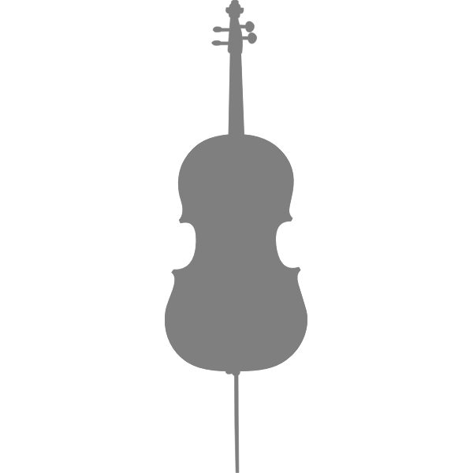
Signature Page for Orchestra II class- Mrs. Misco

Keep the other pages for the important concert dates and information. Please put the dates on your calendar now! I try not to send too many paper notes home to conserve paper. I will send email and reminders, but get the dates on your calendar!

Student Name _______________________________________________(print first and last)

We have read and agree to the Orchestra II disclosure and grading policies. We support practicing at home, being prepared for class, and being at every class rehearsal possible. Class rehearsal time is incredibly important, and there is no way to completely make up a missed rehearsal. Students will need to submit regular recordings on Canvas. We have also read the Concert Dates and Policies and will plan on the concerts ahead of time and follow the policies and dress code.
IMPORTANT- We will bookmark Hillsideorchestra.weebly.com as this web page contains all concert dates, important class information, videos and other announcements.

Student Signature_________________________________________________

Parent or Guardian Signature__________________________________________________

Parent name and e-mail address or phone________________________________________

